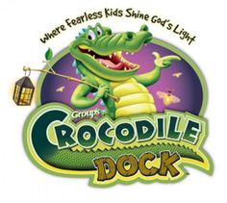
VACATION BIBLE SCHOOL

August 2, 3, & 4, 2021
5:30–6 pm Dinner
6:00 pm – 8 pm VBS
“FREE EVENT”

Music, Crafts, Games, Bible Stories,
& Tons of Fun!!
Ages 4 to 5th grade (completed)
Please register @ office@bushcreekchurch.org
If you have any questions or concerns please call Chontelle Hockenbery@301.252.6308
Bush Creek Church of the Brethren
4821A Green Valley Road
Monrovia, Md. 21770
301-865-3013 www.bushcreekchurch.org
Note: We will follow MD & CDC guidelines effective at the time. Follow us on

